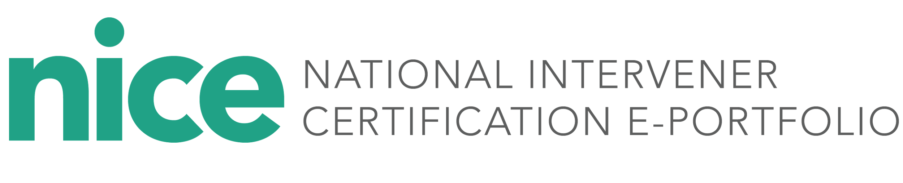

**Intervener Candidate Information Form**

Name:

Date:

1. After reviewing the CEC competencies, I think I am strong in the areas of:
2. After reviewing the CEC competencies, I think I am not so strong in the areas of:
3. I am most excited about working with a mentor because:
4. I am most nervous about working with a mentor because:
5. I learn best when I . . . (e.g., talk about ideas with another person, read and think on my own, see examples to guide my thinking):
6. I would like to receive support from my mentor via . . . (e.g., email, phone, in person, Facetime, Skype, Google Hangout):
7. Pieces of documentation I already have available to start building my e-portfolio:
8. My comfort level with using technology tools to create and upload video, images, and documents (1-5) and why:
9. Date on which I would like to submit my microcredential or portfolio:

Signature___________________________