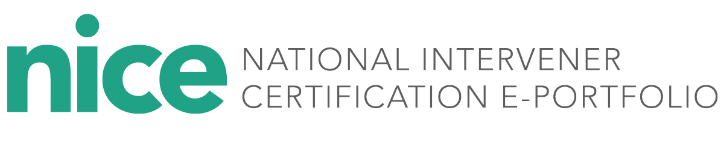

The Intervener Microcredentials and National Intervener Certification E-portfolio (NICE), offered through the Paraprofessional Research and Resource (PAR²A) Center at the University of Colorado Denver, provide a flexible and nationally recognized pathway for interveners working with students who are deaf-blind.

**Empowering Interveners: Microcredentials Leading to National Certification**

**Getting to Know the New NICE!**

The NICE system was originally created in 2016 through a collaboration between the PAR²A Center at the University of Colorado Denver and the National Center on Deaf-Blindness (NCDB), funded by the Office of Special Education Programs (OSEP) as a national, non-credit certification option for interveners. Since then, candidates from over 20 states have achieved certification. In 2024, the NICE program was fully transitioned to the PAR²A Center and was restructured into seven flexible microcredentials aligned with the CEC Intervener Standards. Completing all seven leads to the full NICE Certification.

**Why Choose Intervener Microcredentials and NICE?**

* ***Innovative and Standards-Based***: Aligned with the CEC Intervener standards
* ***Flexible and Focused:*** Particularly suited for in-service paraeducators who support deafblind students as it allows candidates to complete one microcredential at a time, focusing on specific skill areas.
* ***Rigorous Assessment:* Each submission is evaluated by experts in deaf-**blindness and intervener training to ensure high standards of quality and competence**.**
* ***Professional Growth Focused***: Portfolio development encourages reflection and practice improvement. Detailed feedback from reviewers supports ongoing growth and development.
* ***Mentor-Supported:*** Every candidate is paired with a mentor who provides personalized, hands-on coaching throughout the process.
* ***Affordable:*** Microcredentials range from $25 to $75 each, based on the number of associated CEC competencies. The total cost to complete all seven microcredentials and earn full NICE certification is $350.
  + Interveners who wish to apply for certification should contact their state deaf-blind project or college/university training program to discuss pursuing intervener Microcredentials and full certification.

**How to Apply**

* + The state project or university partner may assist the intervener in assessing his or her readiness to engage in the microcredential and certification process and assign a mentor to provide guidance and feedback during portfolio development.
  + Every candidate must complete the PAR2A Center training module explaining the use of the NICE system.

**Testimonials**

*“I felt more confident in my role as a reviewer and that I was ready to review a NICE portfolio after the Reviewer Group training.”*

* NICE Reviewer

*“Gave me the ability to become certified and showcase my life’s work”*

* NICE Completer

*“The biggest benefit to me personally has been learning how to talk about my work and explain it to others; I also enjoyed the self-reflection process once I got the hang of it. I hope it will also become beneficial as a way to help interveners gain more recognition as professionals in the near future.”*

– NICE Completer

*“It helps you see your strengths and weaknesses.”*

* *NICE Completer*

**Visit** [**https://paracenter.org/nice/**](https://paracenter.org/nice/)

**For more information contact:**

**Dr. Ritu Chopra**

**The PAR2A Center**

[**ritu.chopra@pucdenver.edu**](mailto:ritu.chopra@pucdenver.edu)

**or**

