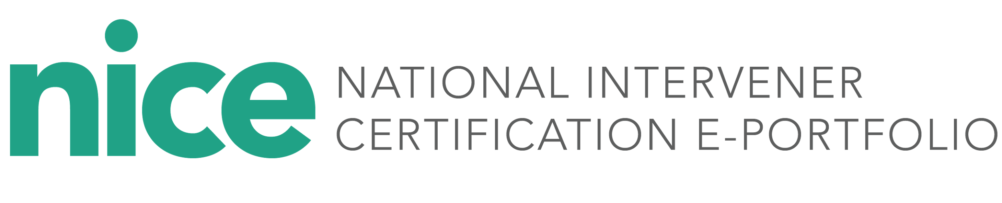

**Mentor Information Form**

Mentors, please complete this form and share a copy with the candidate you are mentoring and the designated state deaf-blind project or university partner.

Date:

Name:

Preferred Phone:

Email:

Preferred contact method and best time of day and days of the week to meet:

Discipline/areas of expertise:

Endorsements, licensure, certification areas (if applicable):

I want to be a mentor in the NICE process because:

To me, our mentorship relationship looks like:

Signature _____________________________ Date_______________________